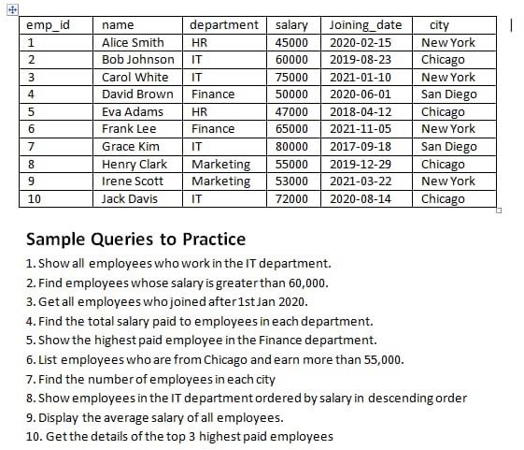
- Show all employees who work in the IT department.
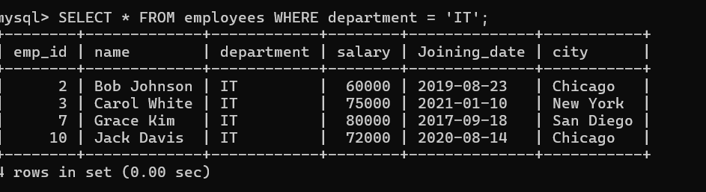

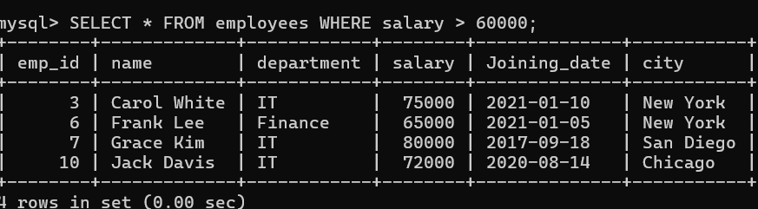
- Find employees whose salary is greater than 60,000.

- Get all employees who joined after 1st Jan 2020.
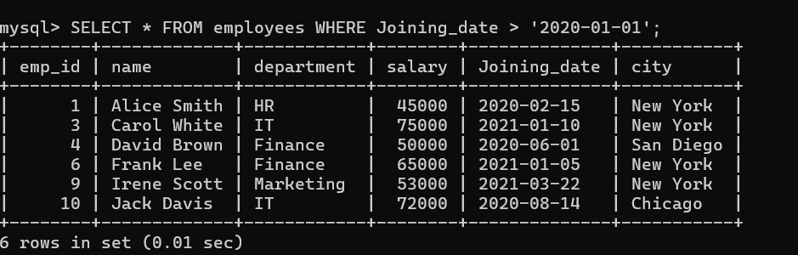

- Find the total salary paid to employees in each department.
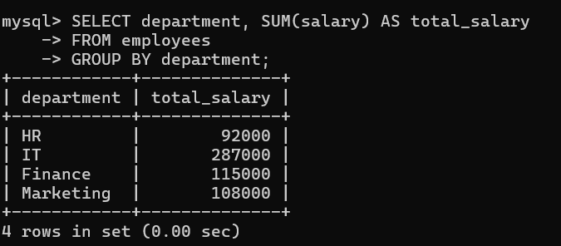

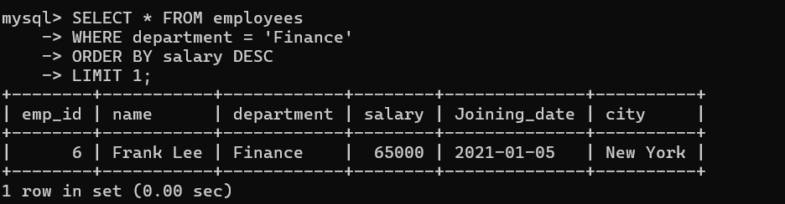
- Show the highest paid employee in the finance department.

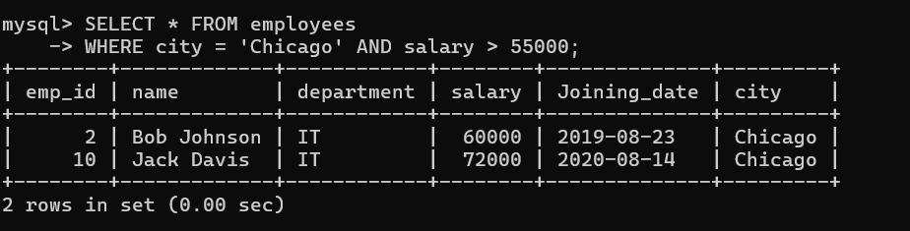
- List employees who are from Chicago and earn more than 55,000.

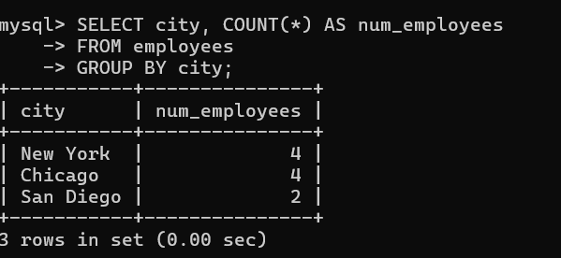
- Find the number of employees in each city.

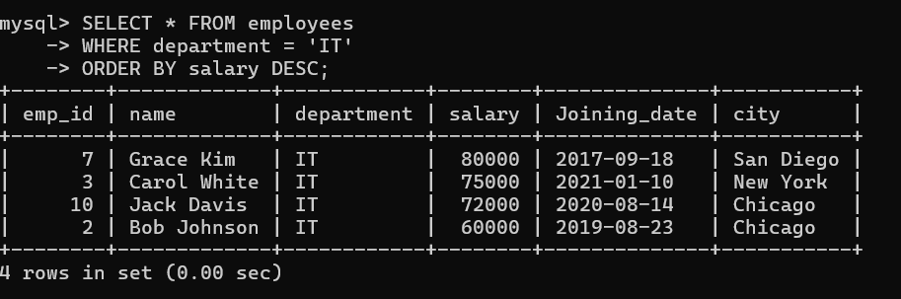
- Show employees in the IT department ordered by salary in descending order

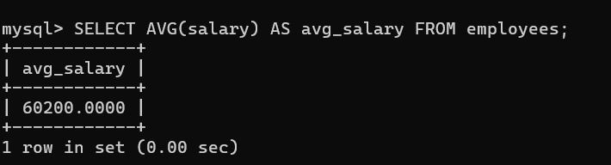
- Display the average salary of all employees.

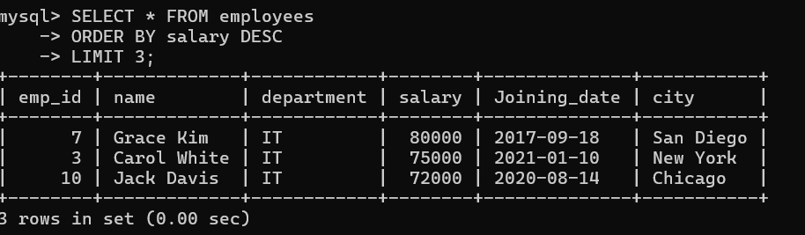
- Get the details of the top 3 highest paid employees.

